**DIABETES MANAGEMENT WITH CHATBOT**

BY

CHIN YAN

A project report submitted in partial fulfifilment of the   
requirements for the award of Bachelor of Science (Hons.)  
Applied Mathematics With Computing

Faculty of Engineering and Science  
Universiti Tunku Abdul Rahman

August 2019

# DECLARATION OF ORIGINALITY

I hereby declare that this project report entitled **“DIABETES MANAGEMENT WITH CHATBOT”** is my own work except for citations and quotations which have been duly acknowledged. I also declare that it has not been previously and concurrently submitted for any other degree or award at UTAR or other institutions.

|  |  |
| --- | --- |
| Signature : | ______________________________ |
| Name : | _CHIN YAN___________________ |
| ID No. : | _1101942______________________ |
| Date : | _August 2019___________________ |

**APPROVAL FOR SUBMISSION**

I certify that this project report entitled **“DIABETES MANAGEMENT WITH CHATBOT”** was prepared by **CHIN YAN** has met the required standard for submission in partial fulfilment of the Requirements for the award of Bachelor of Science (Hons.) Applied Mathematics With Computing at Universiti Tunku Abdul Rahman.

Approved by,

|  |  |
| --- | --- |
| Signature : | _______________________ |
| Supervisor : | _______________________ |
| Date : | _______________________ |

The copyright of this report belongs to the author under the terms of the copyright Act 1987 as qualified by Intellectual Property Policy of University Tunku Abdul Rahman. Due acknowledgement shall always be made of the use of any material contained in, or derived from, this report.

© 2019, CHIN YAN. All rights reserved

**ACKNOWLEDGEMENTS**

I want to thank my parents for their support and thank my supervisor, my

lecturers as well as my friends for their help.

CHIN YAN

**DIABETES MANAGEMENT WITH CHATBOT**

CHIN YAN

**ABSTRACT**

Chatbot is an application that automates a conversation between human and computer program in the form of either text or audio. Chatbot application usually design in such a way that mimic human conversation pattern as how actual people will response. In this project, a chatbot that will simulate the conversation of doctor that diagnose prediabetes and give advice based on diagnosis result will be implemented as a web application. This application will be important to aiding the early detection of diabetes, because via internet connection user will able to do self diagnosis at anywhere or anytime. The early detection is main factor that lead to effective diabetes management. Beside that, this application is also design to aid the user do health monitoring, so that user able to prevent diabetes.

The application will be implemented in Python and Flask micro-framework as the server side program. The user interface(UI) will be implemented in Javascript and Jquery library. Python and Javascript are chosen because they are open source, well documented and user friendly. They are suitable for personal use and education purpose.

This is how the program flow. First, the chatbot will prompt and get the age, gender, status of gestational diabetes, status of diabetes family history, status of high blood pressure, status of physically active, weight(kg) and height(cm) from the user. Based on the model of America Diabetes Association(ADA), the program will generate and return the diagnosis result. For the model result, the bot will trigger warning to user and give advice to user to improve their health on weight management particularly on diet calories quota control and physically activities.

### Table of Contents

Title i

Declaration Of Originality ii

Approval Of Submission iii

Acknowledgement v

Abstract vi

Chapter 1 : Introduction 1

1-1 Research Background 1

1-2 Objective 2

1-3 Problem Statement 2

Chapter 2 : Literature Review 3

2-1 Diebetes Milletus 3

2-2 Type 2 Diabetes as Inflammatory Diesease 3

2-3 Risk Factor of Diabetes 4

2-4 Diagnosis of Diabetes 5

2-5 Visceral Fat and Weight Management 5

2-6 Basal Metabolic Rate and Calories Quota 6

2-7 Glycemic Index and Blood Sugar Stability 6

2-8 Essential Fatty Acid Omega 3 and Omega 6 7

2-9 High Protein Diet in Weight Management 8

2-10 Dietary Fiber 8

2-11 Guideline on Calories Control 9

Chapter 3 : Methodology 10

3-1 Chatbot Development Framework 10

3-2 Web Application 11

3-3 American Diabetes Association Model 11

3-4 Mifflin St. Joer Basal Metabilic Rate Equation 13

3-5 Body Mass Index for weight management 14

Chapter 4 Results 15

4-1 Application Implementation 15

Chapter 5 : Discussion 25

5-1 Limitation of the Project 25

Reference: 26

Chapter 1 : Introduction

* 1. Research Background

According to World Health Organization, the major cause of premature death(over 85%) today are None Communicable Disease(NCD). In 2016 among top 10 causes of death, 9 out of 10 are NCD, diabetes ranked number 7. Diabetes alone killed 1.6 million people in 2016. Diabetes will cause a lot of serious complication. If never pay attention at diabetes, over the time it will damage blood vessels, heart, kidney, eyes and nerves. Adult with diabetes is 2 to 3 times riskier to get heart disease or stroke. Diabetes is also leading causes of kidney failure. In the past diabetes only developed in elderly, but now it is increasingly frequent developed in youths, teenagers and even kids.

Chatbot is an application that automates a conversation between human and computer program in the form of either text or audio. Chatbot application usually design in such a way that mimic human conversation pattern as how actual people will response. In this project, a chatbot that will simulate the conversation of doctor that diagnose prediabetes and give advice based on diagnosis result will be implemented as a web application. This application will be important to aiding the early detection of diabetes, because via internet connection user will able to do self diagnosis at anywhere or anytime. The early detection is main factor that lead to effective diabetes management. Beside that, this application is also design to aid the user do health monitoring, so that user able to prevent diabetes.

1-2 Objective

The aim of this project is to design a web application chatbot that able to help people diagnose prediabetes/diabetes, giving people advises and help people do monitoring without go to the hospital. The application would be useful in promote early detection of diabetes which is the key factor of successful diabetes management. This application also, designed to aid people to monitor their health in a weekly basis. This project will implement an application that is user friendly.

1-3 Problem Statement

Research and study were done to compile the causes of diabetes, symptom of diabetes, diagnosis method of diabetes, treatment of diabetes and diabetes management diet, and then study research and master the chatbot development framework. After analysis of the diagnosis method, America Diabetes Association(ADA) Model was chosen as a diagnosis model, a questionaire was then designed to get data form user based on ADA model. A series of conversation between doctor and patient is then written down in a text file. The conversation document is then read and a chatbot model is trained in python program.

This chatbot application was design to run as following flow. First, the bot will give a greeting to user and ask whether user wish to run a diabetes diagnosis. Secondly, the bot will brief user on how the diagnosis work. After the briefing, the bot will start to run the questionnaire and get parameters from user. These parameters is then feed in to ADA model, then the model will discriminate whether the user suffered from prediabetes. Then the bot will tell user about their result and also their what is the weight they need to maintain to improve their health. Furthermore, based on the same parameter, bot will calculate the Basal Metabolic Rate and the diet calories quota for the user. These matric is to aid user do monitoring. Lastly, the bot will have a question and answer section for user.

Chapter 2 : Literature Review

2-1 Diabetes Mellitus

There are three type of diabetes. Type 1 diabetes is insulin dependent diabetes. Type 2 diabetes is non-insulin dependent diabetes. The last one is gestational diabetes. Gestational diabetes is the diabetes that only occur in pregnant women. During pregnancy, gestational diabetes patient will have their blood glucose level boost above average but below diabetes diagnosis level. The gestational diabetes usually fades away after giving birth, but those who had gestational diabetes will likely develop a type 2 diabetes in future. The cause of type 1 diabetes is due to immune system mistaken pancreatic cell that produce insulin as pathogen, hence immune system attack pancreatic cell and the pancreas loss the ability to produce insulin. The cause of type 2 diabetes is due to insulin resistance, which meant body still produce insulin but the body cells lack of sensitivity to insulin. Type 1 diabetes and gestational diabetes are said to be out of control and cannot be prevent, so this project is not design to manage type 1 diabetes and gestational diabetes. Type 2 diabetes on the other hand is mostly prevent able, so this project will focus on Type 2 diabetes.

2-2 Type 2 Diabetes as inflammatory disease

Inflammatory disease defined as inflammatory disorders that result in the immune system attacking the body's own cells or tissues may cause abnormal inflammation, which results in chronic pain, redness, swelling, stiffness, and damage to normal tissues. In the system of a person, components of the immune system changed when obesity. These causes altered levels of specific cytokines and chemokines, changes in the number and activation state of various white blood cell populations and increased death of cells and tissue fibrosis. Together, these changes suggest that inflammation participates in the pathogenesis of Type 2 diabetes. These causes the insulin resistance and pancreatic beta cell dysfunction. So, obesity is the major causes of diabetes. Weight management is the major key to prevent diabetes.

2-3 Risk Factor of Diabetes

Diabetes is non-communicable disease (NCD) in another word, diabetes is the disease that cannot spread by infection. Type 2 diabetes is classified as metabolic disorder disease together with cardiovascular disease and stroke, which mean abnormal chemical reaction in the body changes the normal metabolism process pathogenesis the disease. Metabolism is defined as any chemical reaction that occur within living things. The process of breaking down the sugars and fats into energy is also parts of the metabolism.

Obesity and overweight are the main factors of diabetes. It is a fact that overweight and obesity is vulnerable to diabetes. Especially for those people with excess weight at abdominal. Abdominal fat causes fat cell release pro inflammation chemicals. These chemicals causes body cell less sensitive to insulin. Besides that, genetics is another factor causes diabetes. Diabetes can be inherits from parents. If any of the parent has diabetes children might have develop diabetes at the age after 40. Races is one of the factor of diabetes, there is a study carried out by American Diabetes Association (ADA) , Asian and Pacific Islander youth with type 1 and type 2 diabetes at lower average mean body mass index(BMI).

People who are smoker is at 30% to 40% higher risk of diabetes compare to those people who are not taking cigarette. Cigarette contains a lot of pro inflammation chemical. These chemical will cause body cell loss sensitivity to insulin. Women who developed gestational diabetes during pregnancy will likely to develop type 2 diabetes in future. This is an early symptom of type 2 diabetes mellitus, difficulty of the secretion of insulin during pregnancy appeared to be abnormal ability to secrete insulin. Physically inactive is another factor that causes type 2 diabetes. Nowadays, with present of computer and internet, a lot of office job is created. More and more citizen had a sedentary life style due to work, together with unhealthy eating habits, more and more premature diabetes developed in youth. To consider physically active people needs to walk 30 minutes at a moderate pace or jog for 20 minutes.

2-4 Diagnosis of Diabetes

The most accurate diabetes diagnosis is blood sugar test. It took more than 1 blood sugar test to diagnose diabetes, blood sugar abnormality in any one single test might not sufficient to indicate patient suffer from diabetes. There are 5 types of blood sugar level test, A1C test, fasting blood sugar test, oral glucose tolerance test, two-hour postprandial test and random blood sugar test. Doctor will takes combination of then to diagnose diabetes. In this project a predictive model is used to diagnose pre-diabetes. If user is being diagnose as pre-diabetes positive, chatbot recommend user to do a proper diabetes screening in hospital.

2-5 Visceral Fat and Weight Management

There is two type of body fat in human body. Subcutaneous fat and visceral fat. Subcutaneous fat is the fat stores under the skin, subcutaneous fat usually found in the arms, legs and also under the skin of tummy. Whereas visceral fat is the fat stored inside the abdominal cavity. Visceral fat is evaluated in the scale of 1 to 59. If the person with a visceral fat of 13 or above, an immediate change of lifestyle is recommended. Complication of visceral fat will cause metabolic disorder and several type of cancer. Abundance of visceral fat will causing insulin resistant. Exercise, diet and change of life style can effectively manage diabetes. Exercise for 30 minutes 5 days weekly, inclusive of both cardiovascular training and resistant training is recommended. Exercises boost metabolism which is essential to burn fat. When losing some weight, some visceral fat will lose together with weight. Hence in this project, regardless the user is being diagnosed with pre-diabetes, if the user is obese or overweight, the chatbot will recommend user to have weight manage to prevent diabetes.

2-6 Basal Metabolic Rate(BMR) and Calories Quota

Basal Metabolic Rate (BMR) is the rate of energy consumed at rest to perform basic operations to sustain life, like breathing, blood circulation, nutrition processing and cell prodction. There are several equation are found to estimate basal metabolism rate. In this project, basal metabolism rate will be calculated with Mifflin-St Joer equation. Basal Metabolic Rate is accurate to estimate amount of energy a person needed daily if and only if the person is doing exact nothing. To be realistic there are serveral factor adjustment is needed. For sedentary lifestyle, calories quota will be 1.2 multiply by BMR. For lightly active lifestyle it would be 1.375 times BMR. Whereas moderately active life style calories quota is 1.55 multiply by BMR and very active life style is 1.725 times BMR. In this project, chatbot will advice user to have calories quota control based on these calculation but only limits to sedentary lifestyle and light active lifestyle.

2-7 Glycemic Index(GI) and blood sugar level stability

Carbohydrate is essential parts of diet, but not all the carbohydrates good for health. Glycemic Index(GI) is a ranking which scale from 0 to 100 that measure how rapidly the carbohydrate break down and dissolved into blood stream and causes the blood sugar level to increase, 0 is the slowest and 100 is the fastest. Some evidences indicate consistently consume high glycemic index food is associate with type 2 diabetes. Consuming high glycemic index food causes sudden spike up in blood sugar concentration and rapidly drop in back down later this causes the blood sugar level to be unstable. This condition is some how vulnerable to type 2 diabetes. The carbohydrate with low glycemic index on the other hand, cause the blood sugar level gradually increase and maintain blood sugar level at a lower level for a longer time. Research indicates low glycemic index is effective in weight management and diabetes management. Hence in this project chatbot will advise user to look for low glycemic index food and avoid high glycemic index food. The food with refined flour and refined sugar are high in glycemic index like white rice, white bread, cakes, noodles, porridge and beverage. The food with low and medium glycemic index are usually unprocessed. For example whole grain, oatmeal, brown rice, sweet potatoes and so on.

2-8 Essential Fatty acid Omaga 3 and Omega 6

Fat is another macro-nutrition human body needs in daily operation. Saturated fat and trans-fat are pro inflammation chemicals, diabetes patient should avoid it. There 3 types of polyunsaturated fatty acid omega 3, omega 6 and omega 9. Omega 3 and omega 6 are essential fatty acid which human body can not produce, which mean essential to acquire by consumption. Omega 9 is polyunsaturated fatty acid that can be found in olive oil, egg yolk, and a lot of natural fat inside the plant. However, omega 9 is not essential human body somehow can produce the omega 9 itself. Sufficient amount of omega 6 is good to health, it’s provide protection for human internal organ and omega 6 is import nutrition for the immune system. Too much omega 6 would be harmful, like saturated fat and trans-fat, omega 6 have pro-inflammation properties. When abundance amount of omega 6 in the body will cause obesity and metabolic disease. Omega 6 is usually found in shortening fats, margarine and vegetable oils. Omega 3 in the other hand having anti-inflammation properties. Consuming high omega 3 food is beneficial for improving and prevent metabolic syndrome disease like stroke, cardiovascular disease and diabetes. Omega 3 can obtained from fatty fish like anchovies, sardine, tuna, and mackerel. In daily meal of citizen, there are abundance of omega 6 fatty acid and insufficient amount of omega 3 fatty acid. Together with other unhealthy lifestyle causes the a lot of obesity in youngster, and it is an alarming concern for complication of obesity might occur in near future. Hence, in this project, chatbot will advise user to take more omega 3 and less omega 6 fatty acid food.

2-9 High Protein diet in weight management

Carbohydrate, fat and protein are known as macro-nutrition, they are 3 major nutrition human consume in relatively large quantities compare to other like vitamins, minerals and fiber. Protein is an important nutrition, it’s provides structural support for cell. DNA is made of chains of amino-acid which is the smallest form of protein. Beside that, builds muscle which is essential in weight loss and maintain a good body shape. A high in take of protein boost metabolism, suppress appetite and alter several weight regulating hormone. A lot of calories burn when to digest protein, evident shows high protein diet burns extra 80 to 100 calories daily. Higher protein intake is proved to be efficient in managing visceral fat. After age of 30, human body lose as much as 3% of muscle each year. This causes the basal metabolic rate(BMR) to slow down, slower the BMR, slower the fats burn. As metabolism slowing down, it makes weight lose harder, hence visceral fat management is affected. A high protein diet can prevent both muscle mass lose and metabolism slowing down. Hence in this project, chatbot will recommend user to consume more protein dense food.

2-10 Dietary Fibers

Fiber in a micronutrition in human diet. Dietary fiber is the plant cell wall that found in the fruits and vegetables. High fiber food has a lot of health beneficial properties. High fiber food strengthen immune system, improve digestion and maintain good intestinal health. There is 2 types of dietary fiber, soluble fiber and insoluble fiber. Soluble fiber are the fiber that able to dissolve in water and form a gel like substance. Soluble fiber is beneficial to metabolic disorder management and weight management. Food with soluble fiber usually has low glycemic index. It can moderating blood sugar level and lower the blood cholesterol. Insoluble fiber is the fiber that not able to dissolve in water nor be digested. Its pass through the digestive system as it’s original form. Insoluble fiber is important in maintaining it’s original form. Hence, in this project chatbot will advise user to have high fiber foods.

2-11 Guideline on calories control

With the aid of Basal Metabolic Rate (BMR), it is possible to know how much calories our body needs. Nevertheless when come to a dinner plate. We might not know how much calories we had eaten. Although rough estimation might works for some people who has go through nutritionist special training, but still the perception of 1 serving might vary for every person. It is very difficult estimate calories by just reads the number. Precision nutrition has implemented a better way to get know off our daily calories control without looks at the numbers. The male’s meal plan with proper calories control guideline from precision nutrition is 2 palms size of protein dense food each day, 2 hand-cups size of complex carbohydrate each day, 2 fists size of high carbohydrates food each day and 2 thumbs size of good fats each day. Whereas, the female meal plan is a palm size of protein dense food each day, a hand-cup size of complex carbohydrate each day, a fist size of high carbohydrates food each day and a thumb size of good fats each day. This is way much easy to makes estimation.

Chapter 3 : Methodology

3-1 Chatbot Development Framework

There are two way to made a chatbot. One of the way is to learn natural language processing, and code a chatbot from scratch. The faster way is to create a chatbot using a chatbot development framework. There are a lot of chatbot development framework available online. Basically chatbot development framework can be categorize into 2 types, non-code based chatbot builder and code based chatbot builder. None code based framework is a chatbot development framework that design for people who don’t know coding. The potential of none code based framework is limited, none code based framework has very little natural processing capability. In this project, code based framework is chosen. Code based framework require a little knowledge of programming but it is more flexible in development.

There are usually to type of chatbot, intent based chatbot and flow based chatbot framework. Intent based chatbot framework contained state of art intent classification and name entities classification. Intent based chatbot based of intent classifier to understand user intent, name entities classifier to extract entity from user response and then only generate response. This project is build with flow based chatbot. Flow based chatbot are trained with a series of dialogue document. During conversation, the chatbot retrieve text from user, chatbot matching the user message with the messages in the database based on angular distance and return next sequence of text in the database as response.

The framework used in this project is called chatterbot. Chatterbot is an open source python libraries. The development stage of chatterbot library is stable, which had less dependencies error needs to be fixed. Chatterbot works well with others python framework, it works well with flask framework to create a web application. Furthermore, since the development of chatterbot framework is stable there is a lot of tutorials and sample codes online to learn from.

3-2 Web Development

In this project the back-ended programming was written in python and flask web development framework. An application programming interface (API) was created in with flask in the server program which allowed server sent message to the front end communicate client side program and retrieved the message from client side to the server. After that with chatbot framework, a response was then generated and the sent back to client site.

The client side programming is written in javascript and jquery library. Cascading Style Sheet (CSS) , javascript and jquery is used to design the user interface (UI) of the chatbot web application. Whenever the server returned a message or user posted a message, a function written in javascript and jquery handled the message and post on the UI.

3-3 American Diabetes Association Diabetes Model

The American Diabetes Association diabetes model/questionnaire is used to diagnose prediabetes in this project. This model is created by Doctor Heejung Bang, a professor of bio-statistics University of California by using the data set from the American Center of Disease Control and Prevention(CDC) during 1993. The model is written as below.



Subject to,

  


 1, if user respond is true, i = 1,2,3,4,5,6,7,8,9,10,11

0, if user respond is false

Where,

X1 denotes age at least 60

X2 denotes age less than 60 but at least 50

X3 denotes age less than 50 but at least 40

X4 denotes gender in male

X5 denotes suffered from gestational diabetes

X6 denotes user have parents with diabetes

X7 denotes user have diagnosed with hypertension

X8 denotes user is physically active

X9 denotes user BMI is at least 25kg/m2 but less than 30kg/m2

X10 denotes user BMI is at least 30kg/m2 but less than 40kg/m2

X11 denotes user BMI is at least 40kg/m2

Figure 3.1 : Equation above is the ADA prediabetes risk test model, if the risk score at least 5, then user might suffer from prediabetes.

|  |  |  |  |  |  |  |  |  |
| --- | --- | --- | --- | --- | --- | --- | --- | --- |
| Age | gender | Gestational Diabetes | Diabetic Parents | High blood  pressure | Physically  active | Weight  (kg) | Height  (cm) | score |
| 28 | male | no | no | no | yes | 88.7 | 175 | 2 |
| 60 | female | yes | no | yes | no | 78 | 155 | 7 |
| 20 | male | no | no | no | no | 50 | 160 | 1 |
| 65 | male | no | yes | yes | yes | 59 | 165.5 | 6 |
| 63 | female | no | no | no | yes | 50 | 157.5 | 3 |

Figure 3.2 is the pilot test of ADA model on some simulated data set.

3-4 Mifflin St. Joer Basal Metabolic Rate Equation

The original equation that estimate Basal Metabolic Rate is known as Harris Benedict Equation it was discovered during 1918. Due to the human lifestyle change rapidly, Mifflin St. Joer further revise Harris Benedict Equation and came out with Mifflin St. Joer equation. This equation estimate total daily energy need by as person in rest state. The equation below is the Mifflin St. Joer Equation.



Where,  
X1 denotes body mass in kg  
X2 denotes height in centimetre  
X3 denotes age  
X4 =1 denotes gender is male, 0 otherwise  
X5 =1 denotes gender is female, 0 otherwise  
Figure 3.3 shown the Mifflin St. Joer equation

|  |  |  |  |  |
| --- | --- | --- | --- | --- |
| Age | gender | Weight  (kg) | Height  (cm) | BMR |
| 28 | male | 88.7 | 175 | 1845.75 |
| 60 | female | 78 | 155 | 1287.75 |
| 20 | male | 50 | 160 | 1405 |
| 65 | male | 59 | 165.5 | 1304.375 |
| 63 | female | 50 | 157.5 | 1008.375 |

Figure 3.4 show the pilot test of Mifflin St Joer Equation with the same set of simulated which used to test ADA model.

3-5 Body Mass Index for weight management

Although body mass index (BMI) is not best matric to estimate overweight and obesity compared to waist circumference or visceral fat scale, but BMI is the most convenient matric then everyone know. In this project body mass index is used to measure the tendency of overweight and obesity. BMI at least 25 but less than 30 is overweight and BMI at least 30 is obesity. Hence the chatbot will recommend overweight or obese user to maintain at a weight that BMI is 24. Equation below is the weight recommendation equation.



|  |  |
| --- | --- |
| Height  (cm) | Recommended weight(kg) |
| 175 | 73.5 |
| 155 | 57.66 |
| 160 | 61.4 |
| 165.5 | 65.7366 |
| 157.5 | 59.535 |

Figure 3.5 is the pilot test of weight recommendation equation based on simulated data.

Chapter 4 Results

4-1 Application Implementation

The chatbot application is written in python code and chatterbot library on the server side. The python code below shown the files being reads from directory and the chatbot is under training.

from flask import Flask, render_template, request

from chatterbot import ChatBot

from chatterbot.trainers import ChatterBotCorpusTrainer

from chatterbot.trainers import ListTrainer #Trainer Lib

import os

app = Flask(__name__)

#Create the Chatbot

MedicalBot = ChatBot('Test1', storage_adapter="chatterbot.storage.SQLStorageAdapter",

preprocessors=['chatterbot.preprocessors.clean_whitespace'],

logic_adapters=[

{

'import_path': 'chatterbot.logic.BestMatch',

"statement_comparison_function": "chatterbot.comparisons.levenshtein_distance",

"response_selection_method": "chatterbot.response_selection.get_first_response"

},

{

'import_path': 'chatterbot.logic.LowConfidenceAdapter',

'threshold': 0.35,

'default_response': 'I am sorry, but I do not understand.'

}

],

trainer='chatterbot.trainers.ListTrainer'

)

#Set the trainer

MedicalBot.set_trainer(ListTrainer)

for _file in os.listdir('Diabetes Dialog'):

#Read Training Data

MedicalBotGreeting = open('Diabetes Dialog/greeting.txt', 'r' ).readlines()

MedicalBotAdvises = open('Diabetes Dialog/Advises.txt', 'r' ).readlines()

#Train bot

MedicalBot.train(MedicalBotGreeting)

MedicalBot.train(MedicalBotAdvises)

if __name__ == "__main__":

app.run(debug=True)

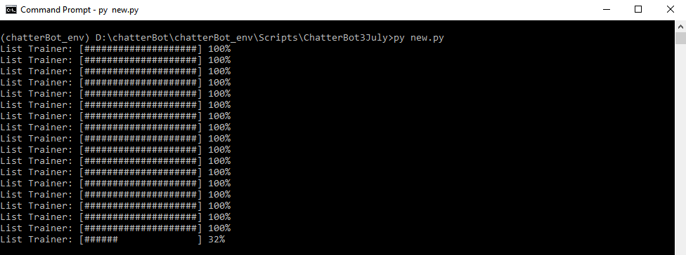

Figure 4.1 shown the chatbot was under training after the python code above in execute.

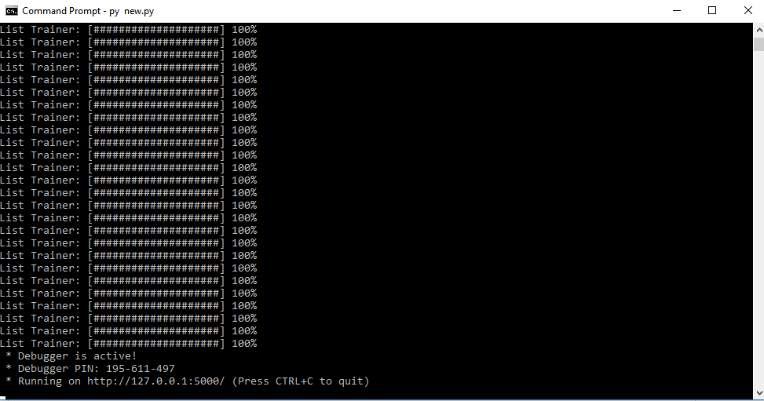

Figure 4.2 shown the commend prompt where the chatbot was done training and ready to be deployed.

When the training is done, it is not necessary to retrain the model. Instead the rendering of the webpage function is added in to the code to render the index.php file.

Besides application programming interface(api) was created.

from flask import Flask, render_template, request

from chatterbot import ChatBot

from chatterbot.trainers import ChatterBotCorpusTrainer

from chatterbot.trainers import ListTrainer #Trainer Lib

import os

app = Flask(__name__)

#Create the Chatbot

MedicalBot = ChatBot('Test1', storage_adapter="chatterbot.storage.SQLStorageAdapter",

preprocessors=['chatterbot.preprocessors.clean_whitespace'],

logic_adapters=[

{

'import_path': 'chatterbot.logic.BestMatch',

"statement_comparison_function": "chatterbot.comparisons.levenshtein_distance",

"response_selection_method": "chatterbot.response_selection.get_first_response"

},

{

'import_path': 'chatterbot.logic.LowConfidenceAdapter',

'threshold': 0.35,

'default_response': 'I am sorry, but I do not understand.'

}

],

trainer='chatterbot.trainers.ListTrainer'

)

#Set the trainer

MedicalBot.set_trainer(ListTrainer)

@app.route("/")

def home():

return render_template("index2.html")

#return render_template("index.backup.html")

@app.route("/get")

def get_bot_response():

userText = request.args.get('msg')

return str(MedicalBot.get_response(userText))

if __name__ == "__main__":

app.run(debug=True)

The codes below was written in the files index.php. The code was writtrn with html, javascript and jquery. This was the code that run at the front-end of the web page.

<!DOCTYPE html>

<html>  
<head>  
<link rel="stylesheet" type="text/css" href="/static/style.css">  
<script src="https://ajax.googleapis.com/ajax/libs/jquery/3.2.1/jquery.min.js"></script>  
</head>  
<body>  
<h1>Medical Chatbot</h1>  
<h3> web implementation of ChatBot by integrating ChatterBot and Vanilla Flask.</h3>  
<div>  
<div id="chatbox">  
<p class="botText"><span>Bot : Hi, I am medical assistance bot. Do you like run a diabetes screening?</span></p>  
</div>  
<div id="userInput">  
<input id="textInput" type="text" name="msg" placeholder="Message">  
<input id="buttonInput" type="submit" value="Send">  
</div>  
<script>

var Counter=0;  
 var score=0;  
 var height = 0;  
 var weight = 0;  
 var age = 0;  
 var gender ="";  
 var physicallyActive = "";  
 var bmr = 0;

function getBotResponse() {

var rawText = $("#textInput").val();

var userHtml = '<p class="userText"><span>' + 'User : ' + rawText + '</span></p>';

$("#textInput").val("");

$("#chatbox").append(userHtml);

document.getElementById('userInput').scrollIntoView({block: 'start', behavior: 'smooth'});

$.get("/get", { msg: rawText }).done(function(data) {

var botHtml = '<p class="botText"><span>' + 'Bot : '+ data + '</span></p>';

$("#chatbox").append(botHtml);

document.getElementById('userInput').scrollIntoView({block: 'start', behavior: 'smooth'});

});

}

function BMR(age,gender,weight,height){

if(gender=='male'){  
return 10*weight + 6.25*height - 5*age + 5;  
}

else{  
 return 10*weight + 6.25*height - 5*age + 161 ;  
 }   
}

function WeightToMaintain(height){

return 24*(height/100)*(height/100)

}

function getResult(){

var bmr = BMR(age,gender,weight,height);

var weightToMaintain = WeightToMaintain(height);

var goodResult = "You got low risk of getting prediabetes. But you can maintain your weight at "+WeightToMaintain(height)+"kg to improve your health";

var badResult = "You got High risk of getting prediabetes. If you suffer from increasingly hungry, "+"increasingly thirsty, fatigueness, slow healing wound, blurry eye,"+

"please seek for medical atttention please seek for medical attention these are symptom of diabetes."+"Weight Management is the key to reverse your condition. You shall maintain your weight at "+WeightToMaintain(height)+"kg";

var rawText = $("#textInput").val();

var userHtml = '<p class="userText"><span>' + 'User : ' + rawText + '</span></p>';

$("#textInput").val("");

$("#chatbox").append(userHtml);

document.getElementById('userInput').scrollIntoView({block: 'start', behavior: 'smooth'});

if(score<5){

var botHtml = '<p class="botText"><span>' + 'Bot : '+goodResult+'</span></p>';

$("#chatbox").append(botHtml);

document.getElementById('userInput').scrollIntoView({block: 'start', behavior: 'smooth'});

}

else{

var botHtml = '<p class="botText"><span>' + 'Bot : '+badResult+'</span></p>';

$("#chatbox").append(botHtml);

document.getElementById('userInput').scrollIntoView({block: 'start', behavior: 'smooth'});

}

}

function getQuestion(ques_id){

var question = ["How old are you?",  
 "What is your gender? (Male, Female)"  
 "Do you ever diagnosed with diabetes during pragnency?"  
 "Do you have a mother, father, sister or brother with diabetes?",  
 "Have you ever been diagnosed with high blood pressure?",  
 "Are you physically active?",  
 "What is your weight status(in kg)?",  
 "What is your Height status(in cm)?"];   
 var rawText = $("#textInput").val();  
 score = score + scoreIncrement(ques_id,rawText);  
 var userHtml = '<p class="userText"><span>' + 'User : ' + rawText + '</span></p>';  
 $("#textInput").val("");  
 $("#chatbox").append(userHtml);  
 document.getElementById('userInput').scrollIntoView({block: 'start', behavior: 'smooth'}); var botHtml = '<p class="botText"><span>' + 'Bot : '+ question[ques_id]+'</span></p>';

$("#chatbox").append(botHtml);  
 document.getElementById('userInput').scrollIntoView({block: 'start', behavior: 'smooth'});

}

function send(){  
 if(Counter<1){  
 Counter++;  
 getBotResponse();  
 }  
 else if(Counter==1){  
 //age  
 Counter++;  
 getQuestion(0);  
 }  
 else if(Counter==2){  
 //gender  
 Counter++;  
 getQuestion(1);  
 }   
 else if(Counter==3){  
 //pregnancy  
 Counter++;  
 getQuestion(2);  
 }  
 else if(Counter==4){  
 //history  
 Counter++;  
 getQuestion(3);  
 }

else if(Counter==5){

//hypertension

Counter++;

getQuestion(4);

}

else if(Counter==6){  
 Counter++;  
 getQuestion(5);

}  
 else if(Counter==7){  
 Counter++;   
 getQuestion(6);  
 }  
 else if(Counter==8){  
 Counter++;  
 getQuestion(7);

}  
 else if(Counter==9){  
 Counter++;  
 getResult();

}  
 else {  
 Counter++;  
 getBotResponse();  
 }  
}  
function scoreIncrement(ques_id, response){

if(ques_id==0){

if(parseInt(response)<40){return 0;}

else if(parseInt(response)>=40 && parseInt(response)<49){return 1;}

else if(parseInt(response)>=50 && parseInt(response)<59){return 2;}

else {return 3;}

}  
 else if(ques_id==1){

if(response == 'Male'|| response == 'male'){  
 gender = response;  
 return 1;  
 }  
 else{  
 gender = response  
 return 0;  
 }  
 }  
 else if(ques_id==2){

if(response == 'Yes'|| response == 'yes'){return 1;}

else{return 0;}

}

else if(ques_id==3){

if(response == 'Yes'|| response == 'yes'){return 1;}

else{return 0;}

}

else if(ques_id==4){

if(response == 'Yes'|| response == 'yes'){return 1;}

else{return 0;}

}

else if(ques_id==5){

if(response == 'No'|| response == 'no'|| response=='not really'){return 1;}

else{return 0;}

}

else if(ques_id==6){

weight = weight + parseFloat(response);

return 0;

}

else if(ques_id==7){

height = height + parseFloat(response);

var BMI = weight/((height/10)*(height/10))

if(BMI>=25.0 && BMI<30.0){return 1;}

else if(BMI>=30.0 && BMI<40.0){return 2}

else if(BMI<=40.0){return 3;}

else {return 0;}

}

}  
 $("#textInput").keypress(function(e) {

if(e.which == 13) {

send();

}

});

$("#buttonInput").click(function() {

send();

})

</script>  
 </div>  
 </body>  
</html>

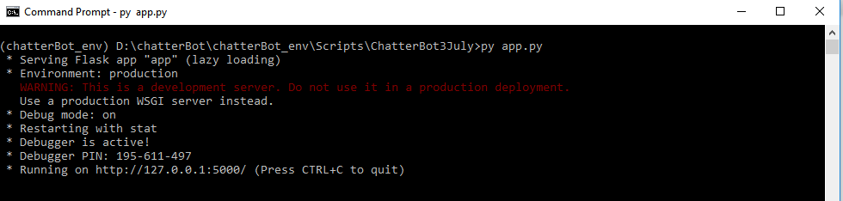

Figure 4.3 shown the commend prompt started a server service without retrain the chatbot model. The chatbot webpages is created at the port number of http://127.0.0.1:5000/

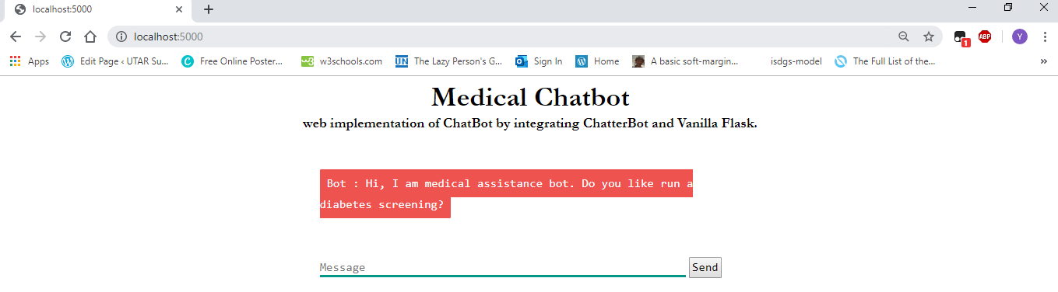

Figure 4.4 shown the User interface of the chatbot with a greeting message from the chatbot.

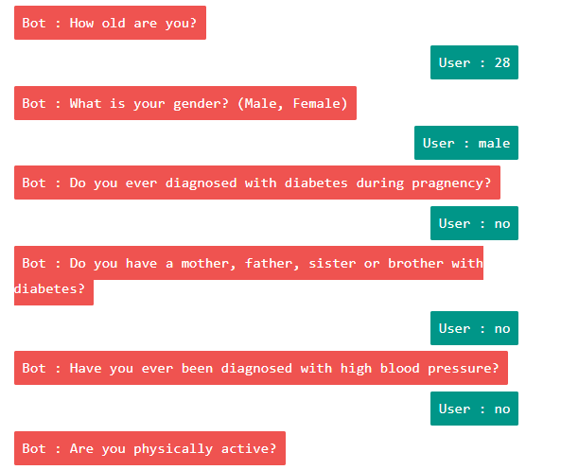

Figure4.5 shown the sample of the chatbot diagnosis.

Chapter 5 : Discussion

5-1 Limitation of the Project

The original aim of design a chatbot is create a program that simulate a chat and convince people it was a human who was chatting. Flow based chatbot might not able to past the turing test. Since the chatbot chat pattern is based on the sequence of the chat data from the database. It would be highly predictable after a few times doing the conversation with the chatbot. Intent based chatbot on the other hand is more close to human thinking process. In human conversation, human was actually guessing the intention of one another through speech. In the intent based chatbot, whenever user send a message to chatbot, chatbot program will do intent classification and name-entities classification, then based on the information extract generate a respond to the user with some words generation algorithm. Hence in user experience, intent based chatbot is more human-like compared with flow based chatbot.

Although, ADA model is able to diagnose diabetes/prediabetes in theoretical approach, but only the real blood sugar test can determine whether user is truly suffer from diabetes. If depend on merely ADA model, it is too fast to jump to conclusion to judge whether a person suffer from diabetes. Since even one single blood sugar test shown a diabetes positive is insufficient conclude a person suffer from diabetes, it is a necessity to run multiple kind of blood sugar test and come out with a solid conclusion.

Reference :

World Health Organization, 2018. *The Top 10 Causes of Death*,[Online]  
available at : <https://www.who.int/news-room/fact-sheets/detail/the-top-10-causes-of-death>

World Health Organization, 2018. *Noncommunicable Disease*,[Online]  
available at : <https://www.who.int/news-room/fact-sheets/detail/noncommunicable-diseases>

1. Y. Donath, S.E. Shoelson, ‘Type 2 Diabetes as Inflammatory Disease’, *Nature Reviews Immunology,* vol. 11, pp. 98 - 107

America Diabetes Association, ‘Classification and Diagnosis of Diabetes ’, *Diabetes Care,* vol. 30,pp. S9-S15

Healthline, *Visceral Fat,* [Online] Available at : <https://www.healthline.com/health/visceral-fat>

1. A. Harris, F. G. Benedict,1918, ‘*A Biometric Study of Human Metabolism* ’, [Online] available at : <https://www.ncbi.nlm.nih.gov/pmc/articles/PMC1091498/?page=1>

Healthline, *Omega3-6-9 Fatty Acids: A Complete Overview,*[Online] Available at:<https://www.healthline.com/nutrition/omega-3-6-9-overview>

Healthline, *How Protein Can Help You Lose Weight Naturally,*[Online] Available

at :<https://www.healthline.com/nutrition/how-protein-can-help-you-lose-weight#section5>

Dr. Griffin S.E., *Soluble and Insoluble Fiber: What is the different,* [Online] Available at:<https://www.myfooddiary.com/resources/ask_the_expert/soluble_insoluble_fiber.asp>

1. Andrew, Brian, *Forget Calories Counting* ,[Online] available at : <https://www.precisionnutrition.com/calorie-control-guide>
2. Cox, 2019, ChatterBot,[Online], available at : <https://chatterbot.readthedocs.io/en/stable/>

Chamkank, 2019,Github,[Online], available at : <https://github.com/chamkank/flask-chatterbot/blob/master/app.py>